Polar Bear Keep this bear white and cut it out and fold it on the dotted line.

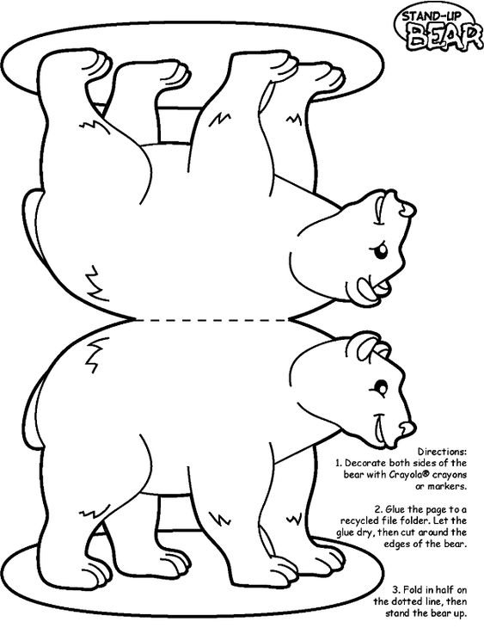
Polar bear

Sun Bear Colour this little bear black with a light snout. Give it long claws.

Sun bear

Moon Bear Colour a light moon on this bear’s chest and the rest black.

Moon bear

Sloth Bear Colour this bear black and shaggy. Give it a long tongue and claws.

Sloth bear

Spectacled Bear Give this little bear some yellow designs on its face and colour its body black.

Spectacled bear

Panda Bear Colour ears, legs and eyes black and leave the rest white.

Panda bear

Brown Bear Colour this big bear brown.
Brown bear

Black Bear Colour this bear all black.

Black bear

